**Faculty of Educational Studies**

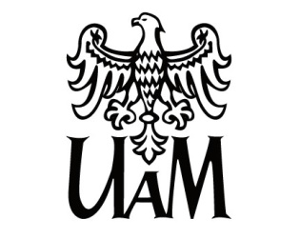

ul. A. Szamarzewskiego 89, 60-568 Poznań, Poland

tel. +48 61 829 23 31

wse@amu.edu.pl

**wse.amu.edu.pl**

International Seminar and Workshops

***Citizenship Education and the Future of Multicultural Democracies***11-12. 06.2025, Poznań, Poland

**11.06 Wednesday, venue: ul. Szamarzewskiego 89, building D, room 508**

**9:00** Opening and Welcome Session of the Seminar

**10:00** Field trip to Primary School “Łejery”, with lecture *Education System in Poland:*Mateusz Marciniak (AMU)

**13:00** Collegium Minus (lunch break)

**14:00** Visiting University

**12.06 Thursday, venue: ul. Szamarzewskiego 89, building D, room 508**

**9:30-10:30** *Citizenship Education, Multiculturalism and the Danger of a Single Story*:   
 Bartosz Hordecki (AMU)

**10:40-12:00** Students’ Presentations

* *Empowering Future Leaders: How Adults Shape Children's Leadership Potential*: Zuzanna Koczorowska, Julia Kwaśny (AMU)
* *Citizenship Education in Germany* - Annika Bleher, Tiara Gerich, Jonas Jülicher, Dominik Kusmierz, Katrin Lehle, Konstanze Linder, Johanna Neidhardt, Katrin Rockermeier, Florian Siegmund, Sonja Waldau.
* *Civic Education in Poland* – Olga Kosakowska (AMU)
* Revitalization of the Śródka district from 2011 to 2025 – Zofia Żurawska (AMU)

**12:00-13:00** *Take the Initiative: a Workshop on Civic Participation*: Joanna Jarmużek (AMU)

**13:00** Farewell Coffee

**17:00** Sightseeing